` `SOME IDEAS FOR USING LEFTOVER YARNS + PATTERNS on pages (2-6) following

1. MAGIC BALL Please use only acrylic yarn as some people are allergic to wool.

Make a ‘Magic Ball’ by tying ends of same-weight yarns together until you get to a grapefruit-sized ball (or bigger, if you prefer.) Ideally, the yarn ends should be secured together with a Russian weave or weavers’ knot but it’s quicker simply to tie them together as the manufacturers do (both ends together, make loop, pull ends through, tug to make sure knot is tight). The more random the colours are, the better! Use the magic balls to knit scarves, stoles, hats, squares, oblongs or strips for blankets or crochet squares/hexagons for a blanket, scarf or shawl (see next pages) or crochet a blanket (moss/granite stitch works particularly well but trebles/v-stitch are faster). Sizes for blankets and patterns for mitts and simple hat etc below.

2. KNITTED SQUARES Please use only acrylic yarn as some people are allergic to wool

Knit garter stitch squares corner to corner. See sizes/instructions on following page. They can also be used for ‘dressing gowns’ – see pattern on Knit for Peace.org.uk

3. KNITTED FINGERLESS MITTS Please use acrylic yarn or clearly label if you use wool

Dividing the yarn balls in half for each colour means you can knit a pair of matching plain or striped fingerless mitts. Easy pattern with size variations below.

4. SCARVES OR STOLES Please use acrylic yarn or clearly label if you use wool

Remembering they must be doubled-sided, crochet scarves or knit in garter, moss stitch, rib, broken rib etc to required width and length – suggested sizes approximately scarf 8-10 inches/20cm-25cm wide by 5 ft/150cm or more long and stole 18inches/40cm wide by 6 ft/180 cm or more long. Guide: Cast on 22 sts = 4 inches/10 cm in DK yarn or as yarn ball wrapper indicates.

5. CROCHET SQUARES/HEXAGONS Please use acrylic yarn only

There are lots of patterns for granny and other squares on the internet but a fast and easy version is below as well as a pattern for hexagons. These can make blankets, shawls, waistcoats etc.

6. SHAWLS Please use acrylic yarn or clearly label if you use wool

Knitted and crochet squares and hexagons can be sewn together in a triangular shape to form a shawl but crochet is better – see patterns/sizes below.

Finished items should be delivered to Age Concern, Cattle Market, Sandwich, CT13 9AP

Squares and strips etc that need to be sewn together can be delivered to Sandwich Library on Thursdays 10-12 or Age Concern Tuesdays 2.30-4.00 where the Craft Group will sew or crochet them together as long as they are to the prescribed sizes shown below.

Patterns on next pages
KNIT PATTERNS Page 2

Lots of ideas and patterns on the website Knit for Peace knitforpeace.org.uk/patterns but our pattern for fingerless mitts is better than theirs! Please feel free to make other warm items to your choice e.g. sweaters, waistcoats, pullovers, cardigans, socks, bedsocks etc of all sizes. All will be needed this winter.
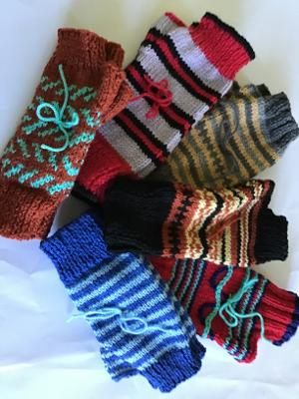
FINGERLESS MITTS
Oddments of DK yarn divided into 2 so each mitt will be the same/4mm knitting needles/2 markers for each mitt. (Tip: safety pins work as markers or even yarn tied into a ring.)
If you knit both mitts at the same time, there’s no tedious counting of numbers of rows for matching purposes.

Cast on 40 sts* leaving 12”/30cm length for sewing up. Rib in whatever sequence you fancy i.e. K2, P2 or K1 P1 or K2 P1 etc for minimum 2 inches or longer to taste ending with a K row.
Using one colour, stripes, fairisle etc to choice, continue in stocking stitch (P one row, K one row) until desired length is reached (at least 24 rows for women’s size) ending with a P row.
Thumb shaping: (right side facing) K2, increase 1 st in next st, place marker then K to last 3 sts, place marker, increase 1 st in next st, K 2 (42 sts). P one row
K to one st before first marker, increase 1 st in next st, slip marker, work to second marker, slip marker, increase 1 in next st, K to end.
P one row
Continue repeating last two rows until there are 52 sts.
Cast off 8 sts at the beginning of the next two rows (36 sts).
Rib as at cuff for a minimum of 8 or more rows to choice. Cast off loosely leaving 6”/20cm end for sewing up rib.
Weave in ends, then sew side seams together by backstitching from wrong side. Sew ribbed top together. Write ‘Large’ ‘Medium’ or ‘Small’ on a your label and attach this to both with an odd length of yarn at the same time securing two mitts together so they don’t lose each other! Please use acrylic yarn or clearly label if you use wool

*For men’s larger size, cast on 44 sts and knit 28 rows instead of 24 or use Aran weight and size 5 needles.
For children, use 4ply and 3.00 or 3.5mm needles.

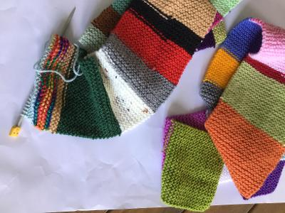
STRIPS FOR BLANKETS (great for using ‘magic balls’) – and overall blanket sizes
Cast on about 24 to 30 stitches to your choice and knit in garter stitch to make long strips to blanket length and sew them together lengthwise. It’s mindless – so great to do while watching TV! The width of each strip is not crucial but the length is.

If you are making an entire blanket, you can make to any of the sizes shown below but, if you are making strips for the Thursday morning Sandwich Library or Age Concern Craft Groups to construct, please only make to Lap Blanket length of 45”/115cm Please use acrylic yarn or clearly label if you use wool

Blanket sizes:
large 70×90”/180x230cm) = strips of 90”/230cm long
medium 50×70”/130x180cm) = strips of 70”/180cm long
baby blankets 24×24”/60x60cm) = strips of 24”/60cm long
lap blankets (45×45”/115x115cm) = strips of 45”/115cm long

Knit patterns (continued) Page 3
KNIT OBLONGS Please use acrylic yarn or clearly label if you use wool
If knit squares or strips don’t appeal, oblongs may. Using only DK on 4mm needles and leaving a tail around 12”/30cm long, cast on 18 sts and knit all rows until there are 32 knit ridges on the right side. Cast off leaving a 12”/30cm tail. These can be plain or striped and should measure 8cm x 16cm. Please use only DK on 4mm needles if Sandwich Library or Age Concern Craft Group is to sew them together.
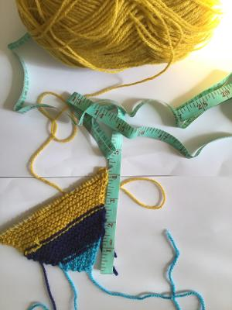
However, if you are making an entire blanket, any yarn thickness will work and you may want to put these together ‘brick wall’ style, in which case you will also need to make ‘half-bricks’ SQUARES 8 x 8 cm: Leaving a tail around 8”/20cm long, cast on 18 sts and knit all rows until there are 16 ridges on the right side. Cast off leaving a 12”/30cm tail. ‘Magic balls’ make good oblongs!

KNIT SQUARES Please use acrylic yarn only
Squares should be knitted on the diagonal, corner to corner and even tiny amounts of yarn can make corners or narrow stripes. If you are making an entire blanket, you can use any weight of yarn and any size but, if you would like Sandwich Library or Age Concern Craft Group to sew them into a blanket, please use DK acrylic yarn on 4mm needles to make a 4” square as below:

Leaving a 10”/25cm tail, cast on 2 sts.
Inc by knitting in front and back of 1st st, K1 = 3sts (give the thread a little tug to make a good corner)
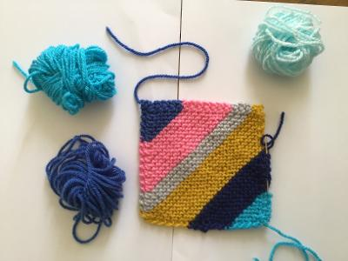
K1, inc 1, K1 = 4 sts
K2, inc 1, K1 = 5sts
K3, inc 1, K1 = 6 sts
Continue in this way, increasing one in the next to last st until you reach 4” at the side (start to measure when you have around 30 sts on the needle). Knit one row without increasing then begin to decrease by knitting to last 3 sts on row, k2tog through back of loop, K1 until you have only 3 sts. K1, K2 tog, pass st over and fasten off leaving tail of 10”/25cm. Sew in ends down sides for security (as shown right.) Tip: a row takes about 3 times its length in yarn.

KNIT HATS ON THE FLAT – IN 3 SIZES Please use acrylic yarn or clearly label if you use wool
It’s best to make the ribbed cuff in just one colour but the remainder can be stripes or from a ‘magic ball’.

Using DK and 4mm needles (and 4 markers), cast on:

Children = 81sts Women = 89sts Men = 97sts

Rib K2 P2 for 5 inches/13cm 6 inches/15cm 6 inches/15cm
Starting with a K row, continue in stocking stitch in plain or stripes for
9 inches/23cm 10 inches/25cm 10 inches/25cm
End with purl row. Shape top:
K2 tog K 16sts 18sts 20sts
Slip 1, psso, place marker 4 times k to end
Purl one row
(K2tog, k to 2 sts before marker, sl1, K1, psso) 4 times K to end
Repeat the last two rows 4 times.
Cut yarn leaving a long end and weave through remaining sts, draw up tightly and fasten off. Sew seam with mattress st. Fold half cuff to right side.

See below for crochet patterns on pages 4 & 5 and where to take finished donated items.
CROCHET PATTERNS Page 4

You will find lots of crochet blanket patterns and easy instructions on the website attic24.typepad.com

Squares – a simple granny square UK crochet terms: Please use acrylic yarn

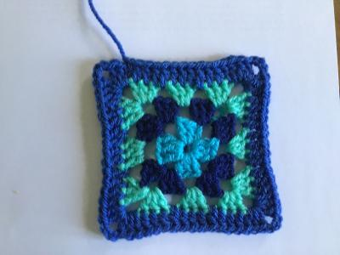
Lovecrafts.com have instructions for some free pattern alternatives and you can find lots on the internet. Any variation is great BUT please make all squares you want the Sandwich Library or Age Concern Craft Group to put together measure at the halfway point 4”/10cm or sewing them together will be problematic.

Chain 4 and join with a slip stitch (ss) to make a ring. (Catch in all ends as you go to save tedious sewing in) or start with magic ring.

Round 1: 3ch, 2tr in ring, 3ch, [3tr in ring, 3ch] 3 times, join with a ss to 3rd of 3ch at beginning of round = 4 corners Fasten off.
Round 2: Join your new yarn into any 3ch space+ (one of the corners of your square), make 3ch, work [2tr, 3ch, 3 tr] all into this same space, 1ch, work *[3tr, 3ch, 3tr] all into corner space, 1ch; repeat from * twice, join with a ss to 3rd st of 3ch at beginning of round. Fasten off.
Round 3: Join your new yarn into any 3ch space (this is always going to be the corner of your square), make 3ch, [2tr, 3ch, 3tr] all into this same space, 1ch, *3tr into next 1ch space, 1ch, work [3tr, 3ch, 3tr] into next 3ch space, 1ch, rep from * twice, 3tr in next 1ch space, 1ch, join with a ss to 3rd of 3ch from beginning of round. If making an entire blanket, repeat this row however many times necessary to achieve size – see Tip below.
Finishing round: Join your new yarn into any 3 ch space (a corner), make 3ch ,* [2tr, 3ch, 3tr] all into this same space, 1 tr in next 3 tr, 1 tr in 1 ch space, 1 tr in next 3 tr *repeat to end. Leave a long end for sewing up two sides.
+Tip: When repeating Round 3 to make a larger square for your own blanket, as the square gets larger, it can begin to ripple. To avoid this, try turning for every new round (also means there is no wrong side) and reduce 3tr at corners to 2tr.
Approximate yarn needed for each square: Sewing Tail 10”/25cm + Round 1 60”/150cm: Round 2 100”/250cm:Round 3 135”/350cm:Round 4 (finishing round) 228”/550cm plus 10”/25cm for sewing.
The finished square in DK on a 4mm hook should measures 4”/10cm across at the centre point. This is the size we need if Sandwich Library Thursday or Age Concern Craft Group are to put them together.
If you want to make a complete ‘granny square’ blanket, any weight or type of yarn is good (but clearly label if you use wool) – see attic24.typepad..com and elsewhere on the internet for instructions and tips on different styles of granny square and edgings etc.
To make a full crochet blanket, attic24typad.com also gives a good idea of how many stitches you need to start off with. For example, for a single blanket or a generous lap blanket/throw, a chain of around 200sts is a good start for a width of around 46”/48” – but the actual number will depend on the stitch and yarn you decide to use (some need an odd number) and your tension. Mostly, exact size does not matter too much and, if you are using ‘magic balls’, it all seems to come out right in the end despite the varying thickness of DK yarns!
The easiest stitch to use is a simple treble but granny clusters stitch and V stitch also work well – as do any of the ripple variations or moss(granite) stitch. There are lots of free patterns on the internet.
Don’t forget to label your work with washing instructions, type of yarn etc.

Hexagons– UK terms Page 5

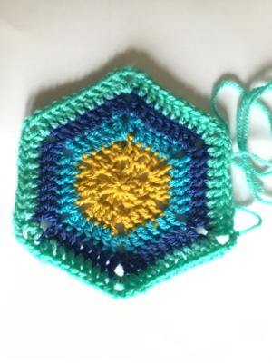
Our pattern, as right, is below. Please use only acrylic yarn or, if you are making an entire item, label clearly if wool since some people are allergic to wool.

If you would like Sandwich Library or Age Concern Craft Group to put these together into a blanket, please use only our pattern and acrylic DK with a 4mm hook so they are (more or less!) all the same size but they can have a different colour for every round or just one colour as you prefer.

Start your hexagon, by making a magic circle and secure with a slip stitch. (Instructions for magic ring online on many websites.) If you can’t manage it, Ch 4 and ss into a ring – but this is not so good as it leaves a bigger hole in the middle.

Round 1: Chain two (counting as 1 tr), then work one treble (tr) into the ring. Chain two and work two tr into the ring. *ch2, tr2* around, until you have six 2tr-clusters separated by ch2. Pull the yarn tail to close the circle, and then finish the round by slip stitching into the back loop of your beginning chain two (or fasten off if changing colours)

Round 2: (Continue in same colour or start new colour in first tr). Chain three (counting as 1 tr), one tr into the next stitch. You have now reached a corner space. Work *1tr, ch 2, 1tr* into the space to create the next corner. Work 1tr into each next 2 stitches (2), and work *1tr, ch2, 1tr* in each corner space. Join the round as Round 1. You should have six corners for your hexagon from now onwards.

Round 3: (Continue with same colour or start new colour in one of tr between corners). Chain three counting as 1 tr, then work one tr into each of the next stitches. Work *1tr, ch2, 1tr* in each corner space around, and work 1 tr in each stitch (4) between corners. Finish the round with a slip stitch or fasten off if changing colours.
Round 4: (Start as Round 3) Chain three counting as 1 tr, then work one tr into each of the next stitches (6). Work *1tr, ch2, 1tr* in each corner space around, and work 1tr in each stitch between corners (6). Finish the round with a slip stitch or fasten off if changing colours.

Round 5: Start as Round 3) Chain three counting as 1 tr, then work one tr into each of the next stitches and *1tr, ch2, 1tr* in each corner space around, working 1tr in each stitch between corners (8) Fasten off leaving a 40”/1m tail for sewing up purposes.

TIP: Approximate lengths of yarns needed
Round 1: 54”/150cm Round 2: 90”/270cm Round 3: 126”/3.25m Round 4: 165”/430cm Round 5: 230”/600cm (includes tail)
The finished hexagon should measure 5”/13cm from flat side to flat side.
A video showing all the steps can be found on crafts.tutsplus.com/tutorials/crochet-fundamentals-how-to-crochet-a-hexagon—craft-9643.

Using just the first two (or three) rounds makes a small hexagon ideal for shawls but you need lots!

There are patterns for other styles of hexagon on the internet if you want to make a complete item e.g. granny cluster hexagons but please keep to this pattern and use acrylic DK on a 4mm hook so they are (more or less!) all the same size if you would like Sandwich Library or Age Concern Craft Group to put these together.
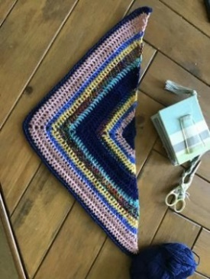
CROCHET Page 6

SHAWLS – see right for one just begun in leftover 4ply but any weight yarn up to Aran weight can be used
The ‘Victoria’ shawl (UK crochet terms) tr = treble, dtr = double treble

Ch4, sl st to make circle
Row 1: ch3, 2tr in ring, ch2, 4tr in ring (8 sts)
Row 2: ch3, 2tr in first st, 1 tr in every st to centre (i.e. the ch 2)
1 tr, 2 ch, 1 tr in centre 2 ch sp
1 tr in every st to end
3 tr in last st.
Turn
Repeat Row 2 until desired size reached, being careful to maintain the right st count on both sides of centre. Sew in loose ends.

Granny Stripe Shawl UK terms
tr = treble, dtr = double treble

Using MC chain 5, sl st into 1st ch to make a circle.
Row 1: Ch 5 (counts as 1 dtr, ch 1 here and throughout), work 3 tr, ch 3, 3 tr, ch 1, 1 dtr in circle, turn – 2 dtr, tr
Row 2: Ch 5, 3 tr in first ch-1 sp, ch 1, [3 tr, ch 3, 3 tr] in centre ch-3 sp, ch 1, 3 tr in last ch-1 sp, ch 1, 1 tr in 4th ch of beg ch 5, turn – 2 dtr, 12 tr
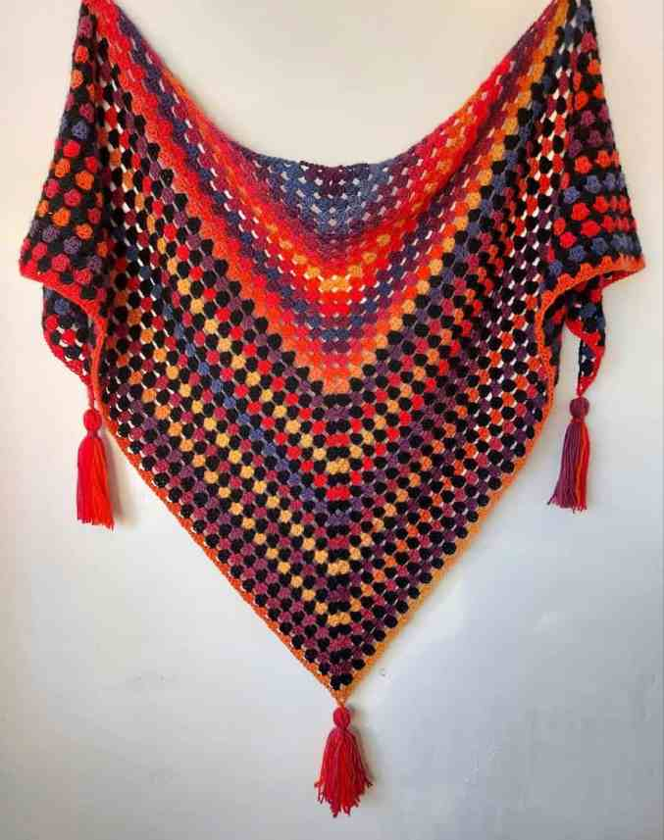
Row 3: Ch 5, [3 tr in next ch-1 sp, ch 1] twice, [3 tr, ch 3, 3 tr, ch 1] in centre ch-3 sp, [3 tr in next ch-1 sp, ch 1] twice, 1 tr in 4th ch of beg ch 5, turn – 2 dtr, 18 tr
Row 4: Ch 5, [3 tr in next ch-1 sp, ch 1] in each ch-1 sp across to centre ch-3 sp, [3 tr, ch 3, 3 tr, ch 1] in centre ch-3 sp, [3 tr in next ch-1 sp, ch 1] in each ch-1 sp across, 1 dtr in 4th ch of beg ch 5, turn.

Rows 5 – end repeat Row 4.

When shawl is big enough, fasten off and weave in all ends.

Scarves
Crochet can also make very good scarves. Simply chain the right amount to give a useful width then use V-stitch, double or treble crochet or any of the many stitch variations you can find on the internet and crochet to a useful length (see Page 1). This is a good way of using up medium-size leftovers but even ‘magic balls’ work for a boho-style scarf. Lovecrafts.com has lots of free patterns.

PLEASE DON’T FORGET TO LABEL YOUR WORK - vital for washing instructions, type of yarn in case of allergies etc. Just write the details on paper and attach to your work so Sandwich Library or Age Concern Craft Group can attach a card label before delivery to residents.

Finished items should be taken to Age Concern, 19-21 Cattle Market CT13 9AP during opening times for delivery to those who need them. You will also find a basket of donated yarns here and at St Peter’s Church, Market Street. Please feel free to donate your spare yarns or to take yarn you need for yourself or to make items for others.

